
INFORMATION TECHNOLOGY P2

NOVEMBER 2016

NATIONAL
SENIOR CERTIFICATE
GRADE 12

MARKS: 150

TIME: 3 hours

This question paper consists of 16 pages.

INSTRUCTIONS AND INFORMATION

1. | This question paper consists of SIX sections:

 | SECTION A:  SECTION B:  SECTION C:  SECTION D:  SECTION E:  SECTION F: | Short Questions (15)  Systems Technologies (25)  Communication and Network Technologies (25)  Data and Information Management (20)  Solution Development (25)  Integrated Scenario (40)

2. | Read ALL the questions carefully.

3. | Answer ALL the questions.

4. | The mark allocation generally gives an indication of the number of facts/reasons required.

5. | Number the answers correctly according to the numbering system used in this question paper.

6. | Write neatly and legibly.

SECTION A: SHORT QUESTIONS

QUESTION 1

1.1 | Various options are provided as possible answers to the following questions. Write down the question number (1.1.1–1.1.5), choose the answer and make a cross (X) over the letter (A–D) of your choice in the ANSWER BOOK.  EXAMPLE:

 | A |  | B |  | C |  | D

1.1.1 | The value of the expression: (8 MOD 3) * (8 DIV 3) is

 | A | 4
 | B | 6
 | C | 5.3333
 | D | 5.9888 |  | (1)

1.1.2 | A digital signature is …

 | A | when someone signs an electronic document.
 | B | used to identify and validate the signer of an electronic document.
 | C | added to an email address as the default signature.
 | D | used to validate an electronic document. |  | (1)

1.1.3 | A Trojan virus is designed to …

 | A | delete all system data.
 | B | gain access to administrator privileges.
 | C | send user information back to a third party.
 | D | appear useful but infiltrate the system. |  | (1)

1.1.4 | A technique used to make electronic communication appear to originate from a legitimate source is known as …

 | A | Spamming.
 | B | Spoofing.
 | C | Spying.
 | D | Streaming. |  | (1)

1.1.5 | Which ONE of the following statements will give the output for iNum of -7, if the following values were assigned to the variables: a = 12 , b = 7 and c = 0 ?

 | A | iNum ← a + b – c * a
 | B | iNum ← c * (a – b) + a
 | C | iNum ← a – c + b * c + 2
 | D | iNum ← b – b * 2 + a * c |  | (1)

1.2 | Give ONE word/term for each of the following descriptions. Write only the word/term next to the question number (1.2.1–1.2.10) in the ANSWER BOOK.

 | 1.2.1 | The amount of data an ISP allows a user to upload and download in a particular time period. |  | (1)
 | 1.2.2 | A website that is regularly updated with news and events in chronological order. |  | (1)
 | 1.2.3 | A person who does steals data or makes unauthorised changes to data. |  | (1)
 | 1.2.4 | An Internet service that translates names e.g. Server1 to an IP address e.g. 169.5.0.1 |  | (1)
 | 1.2.5 | The protocol used for secure transfer of data over the Internet. |  | (1)
 | 1.2.6 | The process whereby the existing contents of firmware are wiped and replaced with an updated version |  | (1)
 | 1.2.7 | Internet based option for exchanging multimedia content in real time. |  | (1)
 | 1.2.8 | A standard for storing digital music by combining efficient compression techniques and good sound quality. |  | (1)
 | 1.2.9 | Gaining access to and making use of a connection an unsecured Wi-Fi network. |  | (1)
 | 1.2.10 | Start-up test performed to ensure that all essential hardware is present and in working order. |  | (1)

TOTAL SECTION A: |  | 15

SCENARIO
A travel agency in the local shopping complex requires the help of the IT learners with the refurbishment of their premises.

SECTION B: SYSTEMS TECHNOLOGIES

QUESTION 2

The travel agency has a LAN in the office building. Each agent will need a computer at their work station.

2.1 | A decision has to be made between fat and thin client computers.
 | 2.1.1 | Motivate the use of thin client computers for the office |  | (2)
 | 2.1.2 | State ONE disadvantage of using thin client computers. |  | (1)

2.2 | When a computer is switched on the processor executes the BIOS program.

 | 2.2.1 | Where is the BIOS found? |  | (1)

 | 2.2.2 | What is the function of the BIOS? |  | (2)

2.3 | One of the factors influencing the performance of a computer is the CPU.

 | 2.3.1 | What is the term used to describe the technique where each CPU works on separate programs at the same time? |  | (1)

 | 2.3.2 | Name and discuss ONE other factor that influences the performance of the computer. |  | (2)

2.4 | What do an interpreter and a complier have in common? |  | (2)

2.5 | Upgrading computer hardware and software should be part of the IT budget.  Suggest TWO ideas that need to be considered when a decision has to be made to upgrade hardware or software. |  | (2)

2.6 | The travel agency wants to limit the amount of electricity they use.

 | 2.6.1 | Besides switching off all computers at night, indicate TWO other ways in which computing devices can save power. |  | (2)
 | 2.6.2 | Suggest TWO ECONOMIC reasons for using computers in the agency |  | (2)

2.7 | .Suggestions: Purpose of archiving files, web caching, web author…… |  | (8)

TOTAL SECTION B: |  | 25

SECTION C: COMMUNICATION AND NETWORK TECHNOLOGIES

QUESTION 3

The cabled LAN in the office building will have access to the Internet.

3.1 | A client-server computer is set up in the main office.

 | 3.1.1 | What is the main advantage of using a client-server network? |  | (1)
 | 3.1.2 | Which hardware device will be used so that the LAN will have Internet access? |  | (1)

3.2 | Motivate, by giving TWO reasons, the use of UTP cables for the network in the office building. |  | (2)

3.3 | Security of client data is essential in the travel business. Malware can attack a computer directly through the network.

 | 3.3.1 | Explain what role password protection and system settings play in stopping malware attacks. |  | (2)
 | 3.3.2 | Explain what a firewall is and how it assists in providing some security to computers on a network. |  | (3)

3.4 | The system administrator will make sure that software is regularly updated.

 | 3.4.1 | Suggest ONE reason for keeping software up to date. |  | (1)

 | 3.4.2 | How would the system administrator update the software? |  | (2)

 | 3.4.3 | Suggest TWO other responsibilities of the system administrator . |  | (2)

3.5 | The technical details of the network connection of a device that is connected to the Internet, contains many numbers.  These numbers refer to TCP/IP and a MAC address amongst others.  What do each of TCP/IP and the MAC address refer to? |  | (2)

3.6 |  |  | ()

 | 3.5.2 | Suggestions: Spam, podcasts, VoIP, compare Windows and linux |  | (9)

3.6.2

3.7
3.7.1

 | 3.7.2
TOTAL SECTION C: |  |  |  |  | 25

SECTION D: DATA AND INFORMATION MANAGEMENT

QUESTION 4

4.1 |  |  | (3)

4.2 |  |  | (2)

4.3 |  |  | (1)

 | 4.4.1 |  |  | (1)
 | 4.4.2 |  |  | (2)

4.5 |  |  | (1)

4.6

(2)

 | 4.6.2
 |  | (a) |  |  | (3)
 |  | (b) |  |  | (3)
 |  | (c) |  |  | (2)
 | 4.6.3
 |  |  |  |  | (5)

TOTAL SECTION D: |  | 20

SECTION E: SOLUTION DEVELOPMENT

QUESTION 5

5.1 | The travel agency provides printed invoices for customers when they pay for their holiday accommodation. The type of accommodation is fixed for example campsite, 4 bed house, B&B, Flat, etc.
The following is an example of a printed invoice:

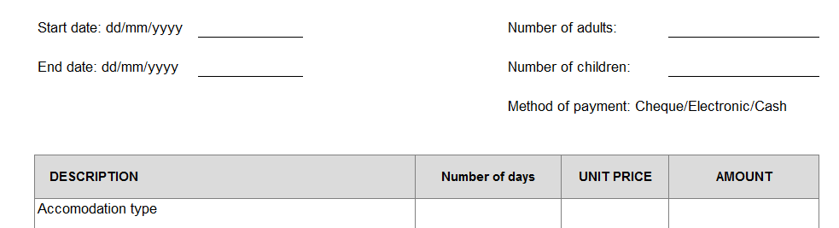
 | 5.1.1 | The information that will be displayed on the invoice must be entered using an interface shown in the example below. To ensure that data is valid, some changes must be made to the interface.  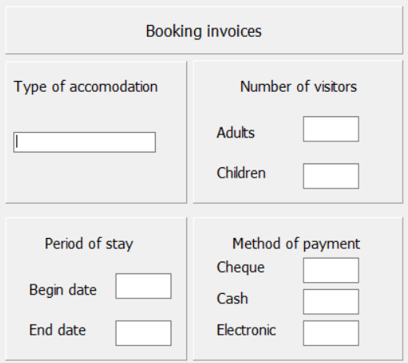  Numbers 1 – 4 indicate different fields that will be used for input of data. In each of the cases (numbers 1 - 4) indicate the best choice of component to use as an input component. |  |  | (4)
 | 5.1.2 | By referring to one of the new components you have suggested on the above form and the input for that component, explain the difference between validating and verifying data. |  | (4)

5.2 | The cost for the accommodation depends on the type of accommodation, the number of adults and the number of children. .  The following is important information:  - The cost for accommodation and type of accommodation is saved in parallel arrays arrCost and arrAccomm.  - A child pays 60% of the cost of the adults.  Given part of an algorithm:  - numDays ← calculated value  - accType ←read in from component  - numAdults ←read in from component  - numChildren ←read in from component  Start at step 5 and complete the algorithm to determine the cost for accommodation |  | (8)
5.3 | The two dimensional array – arrNumbers represented in the table stores the number of visitors to the Funpark and to the Animal park.  NOTE: Only the highlighted information is stored in the array.
 | Number of visitors
 | Funpark | Animal park | Total
January | 1112 | 1321
February | 1943 | 2312
March | 1721 | 1233
April | 1512 | 2312
May | 1412 | 1345
June | 1121 | 1453
July | 2121 | 1732
August | 1211 | 1998
September | 1211 | 2012
October | 2142 | 2901
November | 2132 | 2132
December | 2111 | 2987

Study the algorithm below to answer Question 5.3.1 – Question 5.3.3

      - Declare arrNumbers[12][3]
      - for counter1 ←1 to 12
      - for counter2 ← 1 to 2
      - sum ← sum + arrNumbers[counter1][counter2]

 | 5.3.1 | The total visitors for each month must be stored in the column with the heading Total.

 |  | (a) | Which of the following statements should be used to write the value to the correct position in the 2D array?  (i) Inside the outer loop  (ii) Inside the inner loop  (iii) Outside both loops |  | (1)
 |  | (b) | Rewrite and complete the statement below so that the value will be correctly stored in the 2D array:  arrNumbers[ ][ ] ← sum |  | (2)
 | 5.3.2 | There is a logical error in the algorithm.
 |  | (a) | Explain what is meant by a logical error. |  | (2)
 |  | (b) | Explain what the logical error is and how you will correct it |  | (3)
 | 5.3.3 | Show the changes that will need to be done in lines 2-4 if the sum of the columns must be determined instead of the sum of the row.  (NOTE: You do not need to save the sum in the array)  - for counter1 ←1 to 12  - for counter2 ← 1 to 2  - sum ← sum + arrNumbers[counter1][counter2] |  |  | (3)
5.4 | OOP is a basic programming technique used in modern programming languages.
 | 5.4.1 | What does the abbreviation OOP refer to? |  |  | (1)
 | 5.4.2
  A UML-diagram can be used to represent an object. The following incomplete UML diagram was provided to represent a Booking object.
  Booking
  - accommodationType
  - numAdults
  - numChildren
  - startDate
  - endDate
  - numDays
  + Booking()
  + Booking(accommodationType, numAdults, numChildren)
  - getAccommodationType()
  + calcDays()
  .
  There are two constructor methods named Booking.
 |  | (a) | What is the purpose of a constructor method? |  | (1)
 |  | (b) | What is the principle called when two methods with the same name are created? |  | (1)
 |  | (c) | Motivate whether it is necessary to save the value numDays as an attribute |  | (1)(2)
 |  | (d) | What is the implication of declaring the method getAccommodationType() as a private method.? |  | (1)
 |  |  |  |  | 32

TOTAL SECTION E: |  | 25

SECTION F: Integrated scenario

QUESTION 6

The travel agents will have Internet access as most of the business requires online checking and searching. .

6.1 | The agents will also need access to the company’s Intranet

 | 6.1.1 | What is an Intranet? |  | (2)
 | 6.1.2 | When working from outside the office, suggest one way in which the travel agents could gain access to the Intranet. |  | (1)
6.2 | The agents will be able to use their smartphones to access the company’s network when working outside the office.
 | 6.2.1 | Discuss TWO disadvantages of doing business using a smartphone. |  |  | (2)
 | 6.2.2 | Mobile phone use is very convenient for agents. Motivate the use of mobile devices as a tool for the travel agents. |  |  | (1)
 | 6.2.3 | Which online technique is used to ensure that access on any device will have access to the latest documents? |  |  | (1)

6.3 | A multi-function printer has been ordered for the office and will be accessible on the network.

 | 6.3.1 | What is the difference between a laser printer and an ink-jet printer? |  | (2)

 | 6.3.2 | It has been argued that the image scanner function is a waste.  Suggest another way in which travel documents can be transferred as images to a word processing document. |  | (2)
 | 6.3.3 | Besides sharing the printer on the network, suggest TWO other reasons for networking devices. |  | (2)

6.4 | The administration and accounting side of the business will be run on cloud applications.
 | 6.4.1 | What is the advantage of using cloud applications in a business? |  | (1)
 | 6.4.2 | What software is needed to run cloud application software? |  | (1)

 | 6.4.3 | SaaS (Software as a Service) provides Office365 as an integrated product.  State TWO advantages of using SaaS. |  | (2)

 | 6.4.4 | Explain how cloud computing makes use of virtualisation technologies. |  | (2)
 | 6.4.5 | Briefly describe ONE of the advantages of cloud computing for the travel company.

6.5 | BitTorrent software is blocked on the network in the office.
 | 6.5.1 | What is BitTorrent? |  | (1)
 | 6.5.2 | Suggest TWO benefits of using BitTorrent. |  | (2)

 | 6.5.3 | Sate TWO ways that a user ensure that they are not guilty of piracy when downloading video files? |  | (2)

6.6 | The company’s website has a digital certificate attached.

 | 6.6.1 | Why is it recommended that the company’s website have a digital certificate? |  | (1)

 | 6.6.2 | State TWO details that are found on the certificate. |  | (2)

6.7 | Customers will be able to pay book and pay online. An encryption protocol will be used to send sensitive information across the network

 | 6.7.1 | Explain the term encryption. |  | (2)
 | 6.7.2 | Explain what public key encryption entails. |  | (2)

6.8 | The web page of this agency will be dynamically created as the viewer uses it.

 | 6.8.1 | Explain what a dynamic web page is. |  | (2)
 | 6.8.2 | Compare the way online storage and local storage for affect the creation of web pages. |  | (2)

6.9 | The travel agency’s AUP prohibits the use of social networking sites on the company’s computers.

 | 6.9.1 | What is an AUP? |  | (1)
 | 6.9.2 | What is the purpose of an AUP? |  | (2)
 | 6.9.3 | Motivate TWO reasons for the prohibition of social networking sites at work. |  | (2)

TOTAL SECTION F:  GRAND TOTAL: |  | 40  150

